**PROJECT REPORT**



**PROJECT TITLE:** **LED Flasher Using Arduino UNO**

**With 12 LED’s & Patterns**

**Member:**

Taimoor Nawaz (FA20-BCE-012)

**Subject:**

Microprocessor System & Interfacing (MSI)

**Lab Instructor:**

Engr. Abbas Ali Shah

**COMSATS UNIVERSITY ISLAMABAD**

**(ATTOCK CAMPUS)**

**TITLE:**

**LED Flasher Using Arduino UNO**

**With 12 LED’s & Patterns.**

1. **ABSTRACT:**

The construction and implementation of an LED flasher system utilizing an Arduino UNO microcontroller board are described in this abstract. The goal of the project is to build a flexible and programmable LED lighting system that can generate a variety of patterns from twelve different LEDs. Users may create and control distinctive lighting effects with the system, which takes use of the strength and adaptability of Arduino programming.

1. **INTRODUCTION:**

The project aims to create a captivating LED display by utilizing an Arduino UNO microcontroller, 12 LEDs, and 12 unique patterns. The presentation will cover various aspects of the project, including the circuit diagram, components used, component details, simulation, and Project Video.

1. **CIRCUIT DIAGRAM:**

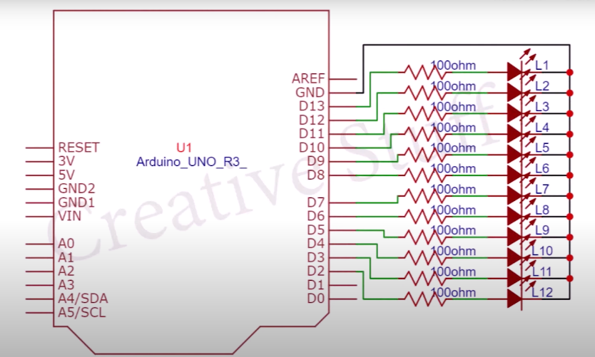

1. **WORKING:**

This Project works by utilizing the Arduino Uno microcontroller's digital pins to control the individual LEDs. Each LED is connected to a separate digital pin, and the Arduino Uno sends signals to these pins to turn the LEDs on and off in a specific pattern. By programming the Arduino Uno with the desired sequence and timing of the LED patterns, the microcontroller executes the instructions and produces mesmerizing visual effects.

1. **COMPONENTS:**

* Arduino UNO
* LED’s
* Resistor
* Bread Board
* Jumper Wires

1. **Arduino UNO:**

Arduino Uno is a popular microcontroller board based on the ATmega328P chip. It is widely used for prototyping and DIY electronics projects. It has digital input/output pins, analog inputs, and various communication interfaces, making it versatile for different applications. The board can be programmed using the Arduino IDE, where users can write code in C/C++ to control the board's functionality.

1. **LED’s:**

LED (Light-Emitting Diode) is a semiconductor device that emits light when an electric current passes through it. It is a compact and energy-efficient lighting solution used in various applications, offering a long lifespan and a wide range of colors. For Example: Red, Green, Red, Yellow, White, Blue, etc.

1. **RESISTOR:**

A resistor is an electronic component that restricts the flow of electric current in a circuit, thereby controlling the amount of voltage or current in the circuit.

1. **BREADBOARD & JUMPER WIRES:**

* A breadboard is a prototyping tool used in electronics to create temporary circuits without soldering.
* A jumper wire is a short electrical wire used to create temporary connections or bridge gaps between components on a breadboard or other electronic circuit.

1. **CODE:**

#define delay50 100

int myled[] = {2, 3, 4, 5, 6, 7, 8, 9,10,11,12,13};

int num_of_leds;

void setup() {

num_of_leds = sizeof(myled) / sizeof(int);

for (int i = 0; i < num_of_leds; i++) {

pinMode(myled[i], OUTPUT);

}

}

void loop() {

delay(1000);

ledonn();

delay(2000);

ledoff();

delay(2000);

for (int i = 0; i < 5; i++) {pattern1();}

for (int i = 0; i < 5; i++) {pattern2();}

for (int i = 0; i < 5; i++) {pattern3();}

for (int i = 0; i < 5; i++) {pattern4();}

for (int i = 0; i < 25; i++){pattern5();}

for (int i = 0; i < 5; i++) {pattern6();}

for (int i = 0; i < 15; i++){pattern7();}

for (int i = 0; i < 15; i++){pattern8();}

for (int i = 0; i < 5; i++) {pattern9();}

for (int i = 0; i < 5; i++) {pattern10();}

for (int i = 0; i < 50; i++){pattern11();}

for (int i = 0; i < 50; i++){pattern12();}

ledoff();

delay(5000);

}

//TURN ON ALL LEDs

void ledonn() {

for (int i = 0; i < num_of_leds; i++) {

digitalWrite(myled[i], HIGH);

}

}

//TURN OFF ALL LEDs

void ledoff() {

for (int i = 0; i < num_of_leds; i++) {

digitalWrite(myled[i], LOW);

}

}

//LEFT TO RIGHT

void pattern1() {

for (int i = 0; i < num_of_leds; i++) {

digitalWrite(myled[i], HIGH);

delay(delay50);

digitalWrite(myled[i], LOW);

}

}

//RIGHT TO LEFT

void pattern2() {

for (int i = num_of_leds; i > 0; i--) {

digitalWrite(myled[i - 1], HIGH);

delay(delay50);

digitalWrite(myled[i - 1], LOW);

}

}

//LEFT TO RIGHT FILL

void pattern3() {

for (int i = 0; i < num_of_leds; i++) {

digitalWrite(myled[i], HIGH);

delay(delay50);

}

for (int i = num_of_leds; i > 0; i--) {

digitalWrite(myled[i - 1], LOW);

delay(delay50);

}

}

//RIGHT TO LEFT FILL

void pattern4() {

ledonn();

delay(delay50);

for (int i = 0; i < num_of_leds; i++) {

digitalWrite(myled[i], LOW);

delay(delay50);

}

for (int i = num_of_leds; i > 0; i--) {

digitalWrite(myled[i - 1], HIGH);

delay(delay50);

}

ledoff();

}

//ALTERNATE LEDs

void pattern5() {

for (int i = 0; i < num_of_leds; i = i + 2) {

digitalWrite(myled[i], HIGH);

digitalWrite(myled[i + 1], LOW);

}

delay(delay50);

for (int i = 0; i < num_of_leds; i = i + 2) {

digitalWrite(myled[i], LOW);

digitalWrite(myled[i + 1], HIGH);

}

delay(delay50);

}

//OSCILLATING LEDs

void pattern6() { //osc

for (int i = 0; i < num_of_leds; i++) {

digitalWrite(myled[i], HIGH);

delay(delay50);

digitalWrite(myled[i], LOW);

}

delay(delay50);

for (int i = num_of_leds; i > 0; i--) {

digitalWrite(myled[i - 1], HIGH);

delay(delay50);

digitalWrite(myled[i - 1], LOW);

}

}

//INSIDE

void pattern7() {

for (int i = 0; i < num_of_leds / 2; i++) {

digitalWrite(myled[i], HIGH);

digitalWrite(myled[num_of_leds - 1 - i], HIGH);

delay(delay50);

digitalWrite(myled[i], LOW);

digitalWrite(myled[num_of_leds - 1 - i], LOW);

}

}

//OUTSIDE

void pattern8()

{

for (int i = (num_of_leds / 2) - 1; i >= 0 ; i--)

{

digitalWrite(myled[i], HIGH);

digitalWrite(myled[num_of_leds - 1 - i], HIGH);

delay(delay50);

digitalWrite(myled[i], LOW);

digitalWrite(myled[num_of_leds - 1 - i], LOW);

}

}

//LEFT TO RIGHT 3 LEDs

void pattern9() {

for (int i = 0; i < num_of_leds + 3; i++) {

if (i <= num_of_leds) {

digitalWrite(myled[i], HIGH);

}

if (i > 2) {

digitalWrite(myled[i - 3], LOW);

}

delay(delay50);

}

}

//OSCILLATING 3 LEDs

void pattern10() {

for (int i = 2; i < num_of_leds; i++) {

if (i == 2) {

digitalWrite(myled[0], HIGH);

digitalWrite(myled[1], HIGH);

}

digitalWrite(myled[i], HIGH);

digitalWrite(myled[i - 3], LOW);

delay(delay50);

}

for (int i = num_of_leds - 4; i > -1; i--) {

digitalWrite(myled[i], HIGH);

digitalWrite(myled[i + 3], LOW);

delay(delay50);

}

}

//RANDOM EFFECT 1

void pattern11() {

int randomnum = random(0, num_of_leds + 1);

digitalWrite(myled[randomnum], HIGH);

delay(delay50);

digitalWrite(myled[randomnum], LOW);

delay(delay50);

}

//RANDOM EFFECT 2

void pattern12() {

int randomonn = random(0, num_of_leds + 1);

int randomoff = random(0, num_of_leds + 1);

digitalWrite(myled[randomonn], HIGH);

digitalWrite(myled[randomoff], LOW);

delay(delay50);

}

1. **SIMULATION:**

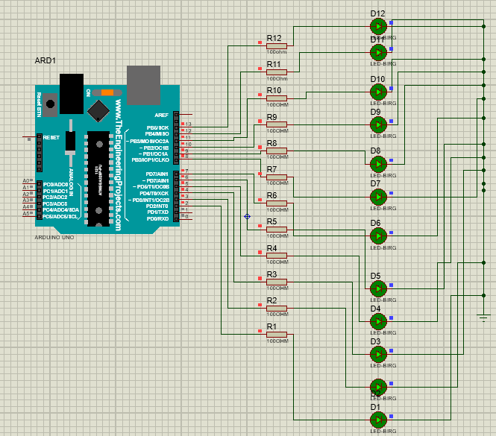

**CONCLUSION:**

In conclusion, the LED Flasher project, which makes use of an Arduino UNO board with 12 LEDs and different patterns, has illustrated the adaptability and creative possibilities of systems based on microcontrollers. We have successfully built a dynamic lighting display that can create compelling visual displays by utilizing the strength of Arduino and the simplicity of LED components.